[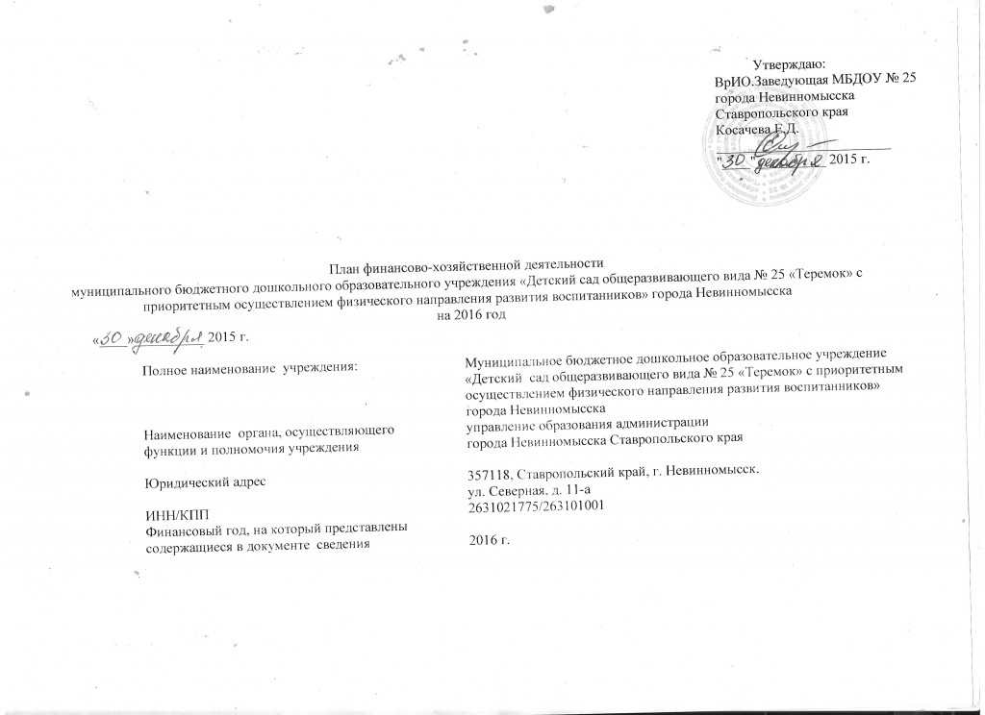](http://ds25.nevinsk.ru/wp-content/uploads/2015/02/ScanImage377.jpg)

[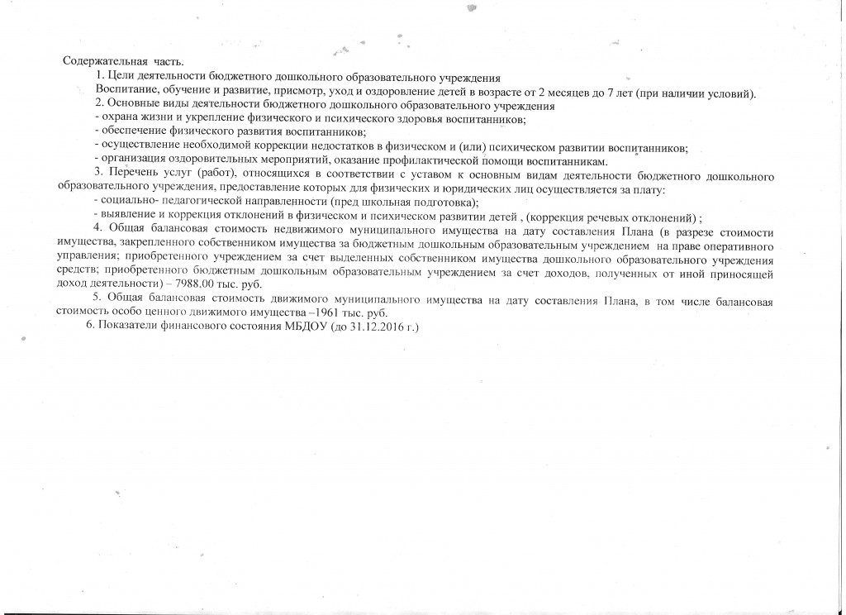](http://ds25.nevinsk.ru/wp-content/uploads/2015/02/ScanImage378.jpg)

[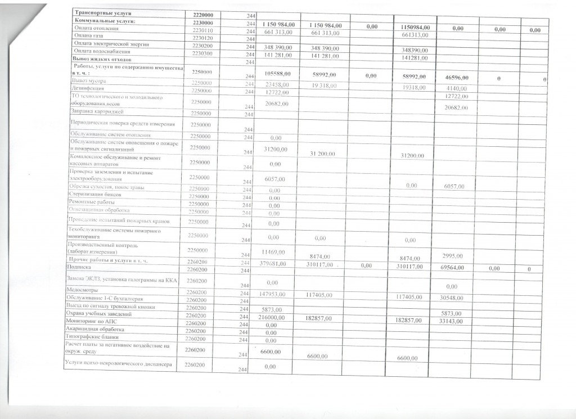](http://ds25.nevinsk.ru/wp-content/uploads/2015/02/25-%D0%BF%D0%BB%D0%B0%D0%BD-2016-001.jpg)

[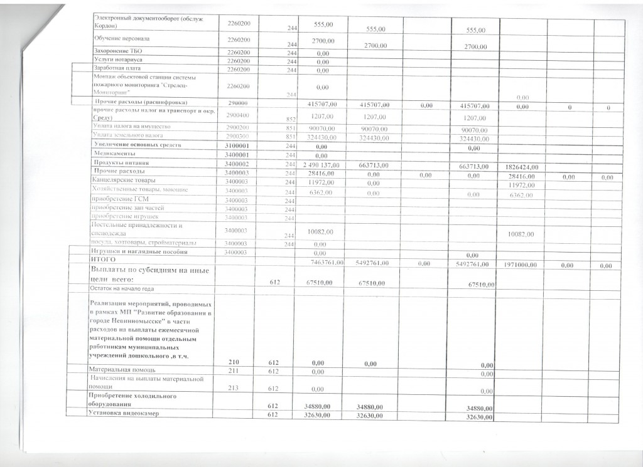](http://ds25.nevinsk.ru/wp-content/uploads/2015/02/25-%D0%BF%D0%BB%D0%B0%D0%BD-2016-002.jpg)

[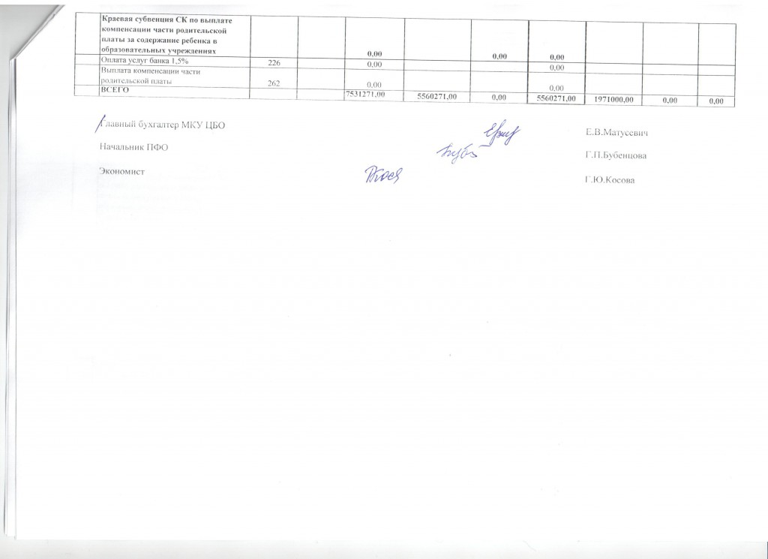](http://ds25.nevinsk.ru/wp-content/uploads/2015/02/25-%D0%BF%D0%BB%D0%B0%D0%BD-2016-003.jpg)