[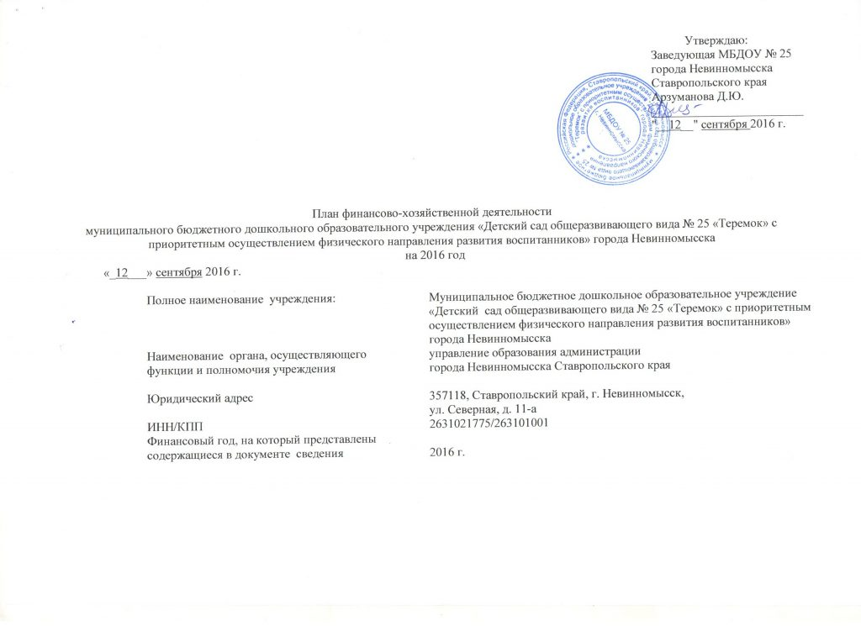](http://ds25.nevinsk.ru/wp-content/uploads/2014/10/1.jpg)

[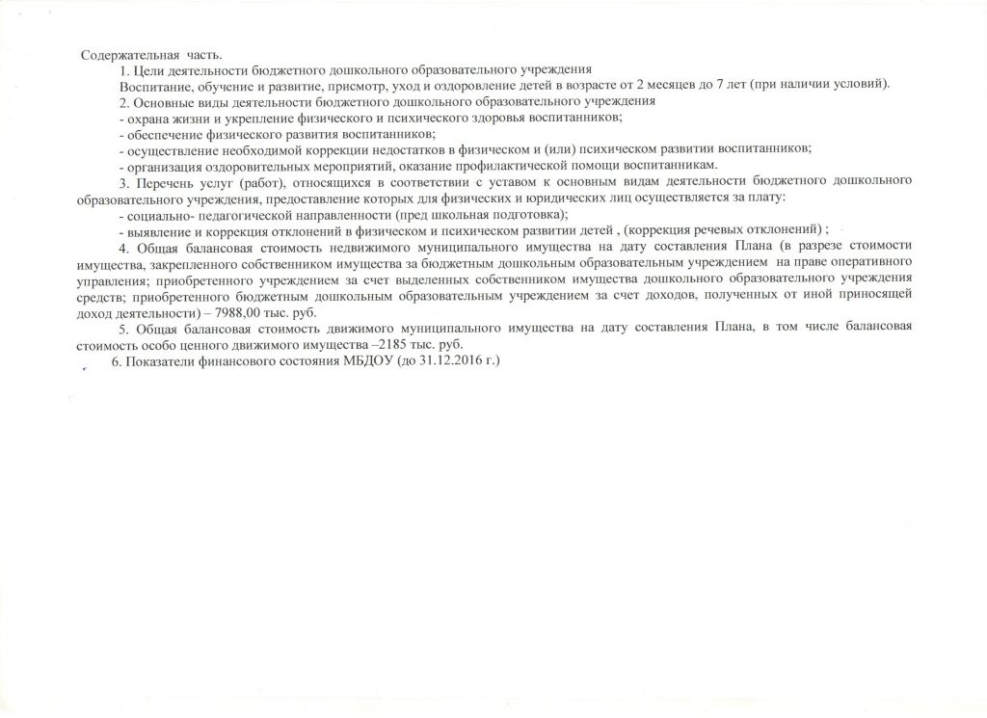](http://ds25.nevinsk.ru/wp-content/uploads/2014/10/2.jpg)

[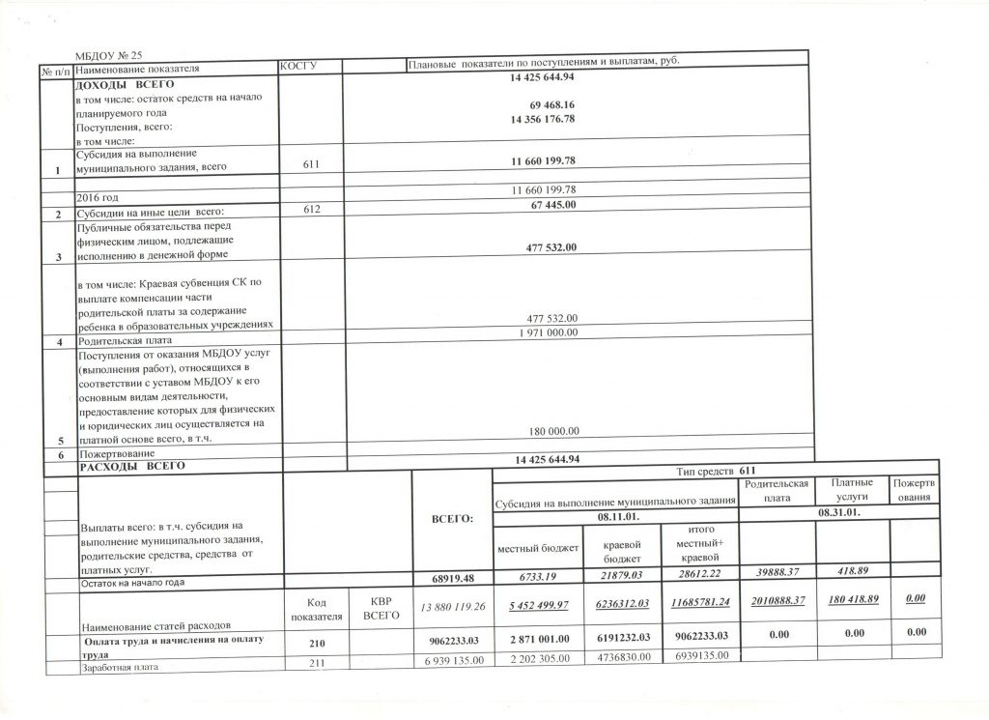](http://ds25.nevinsk.ru/wp-content/uploads/2014/10/3.jpg)

[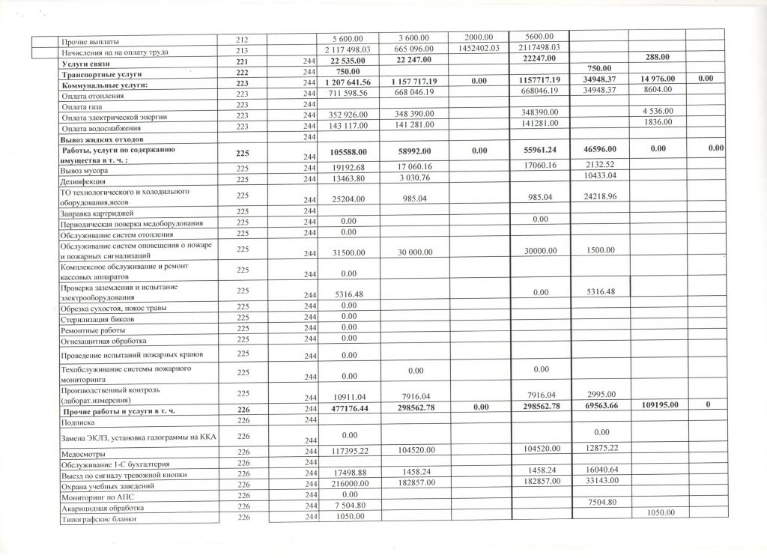](http://ds25.nevinsk.ru/wp-content/uploads/2016/09/%D0%A0%D0%B8%D1%81%D1%83%D0%BD%D0%BE%D0%BA-91.jpg)

[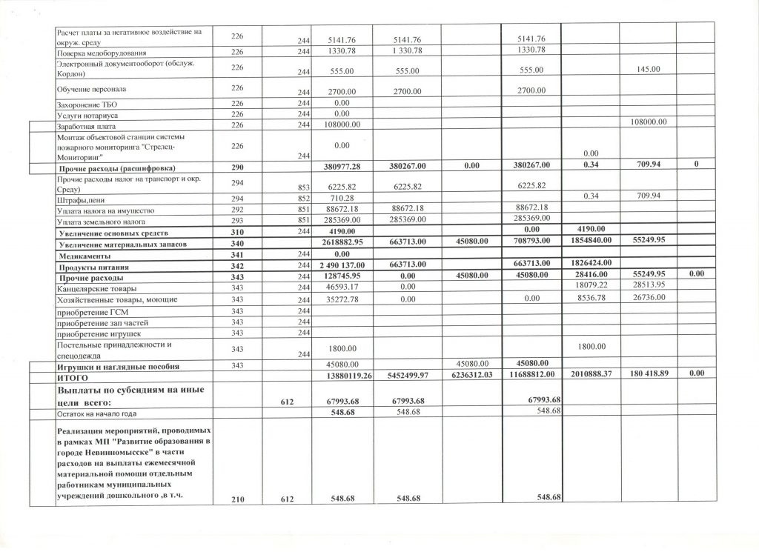](http://ds25.nevinsk.ru/wp-content/uploads/2014/10/5.jpg)

[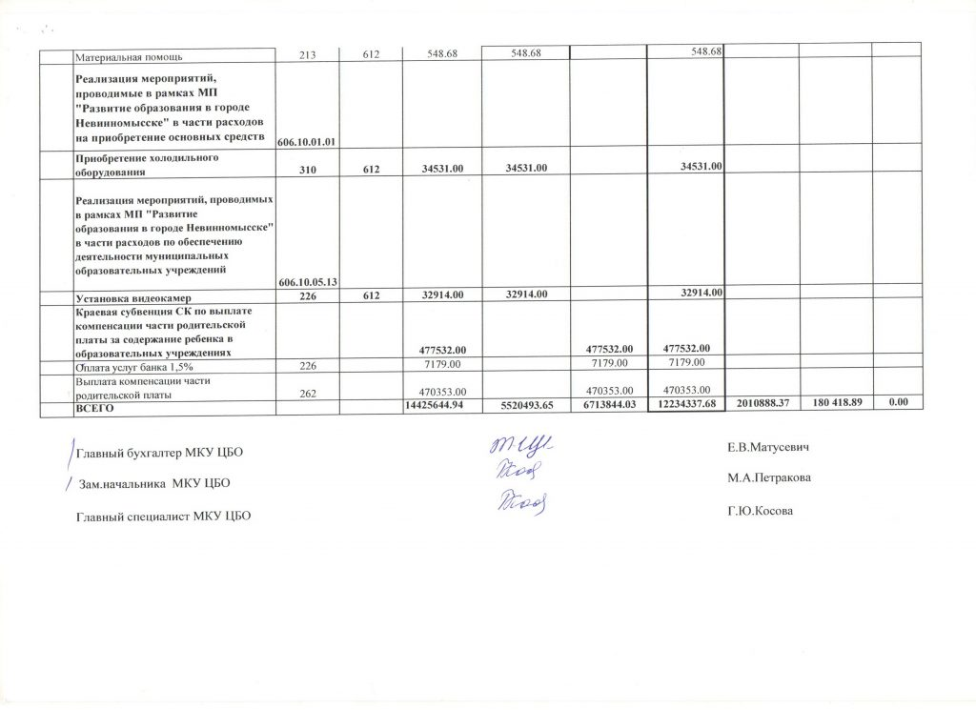](http://ds25.nevinsk.ru/wp-content/uploads/2016/09/%D0%A0%D0%B8%D1%81%D1%83%D0%BD%D0%BE%D0%BA-93.jpg)