[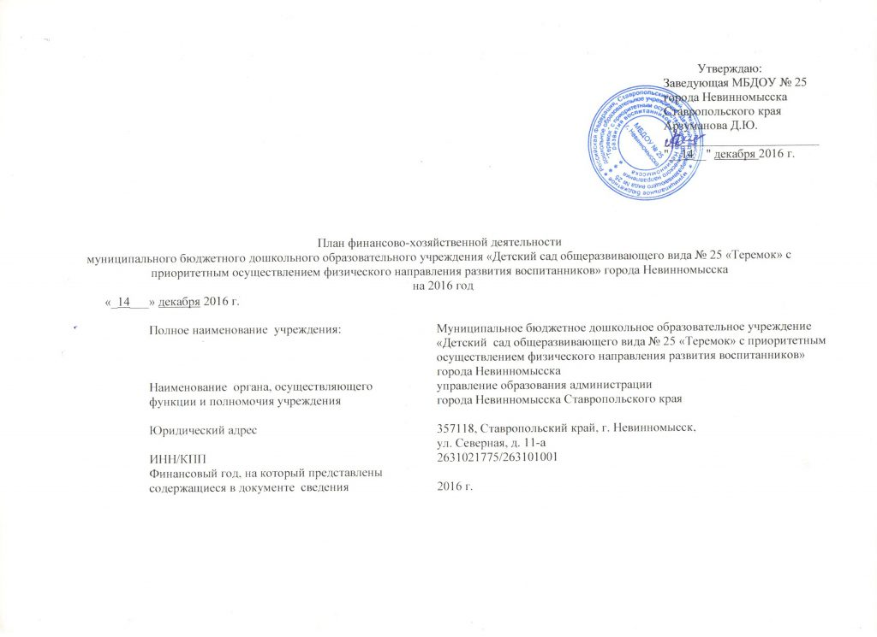](http://ds25.nevinsk.ru/wp-content/uploads/2016/09/%D0%A0%D0%B8%D1%81%D1%83%D0%BD%D0%BE%D0%BA-177.jpg)

[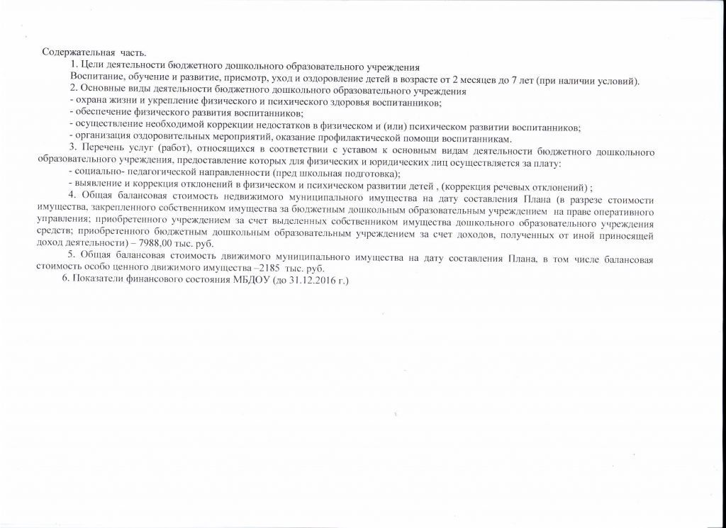](http://ds25.nevinsk.ru/wp-content/uploads/2016/09/2-001.jpg)

[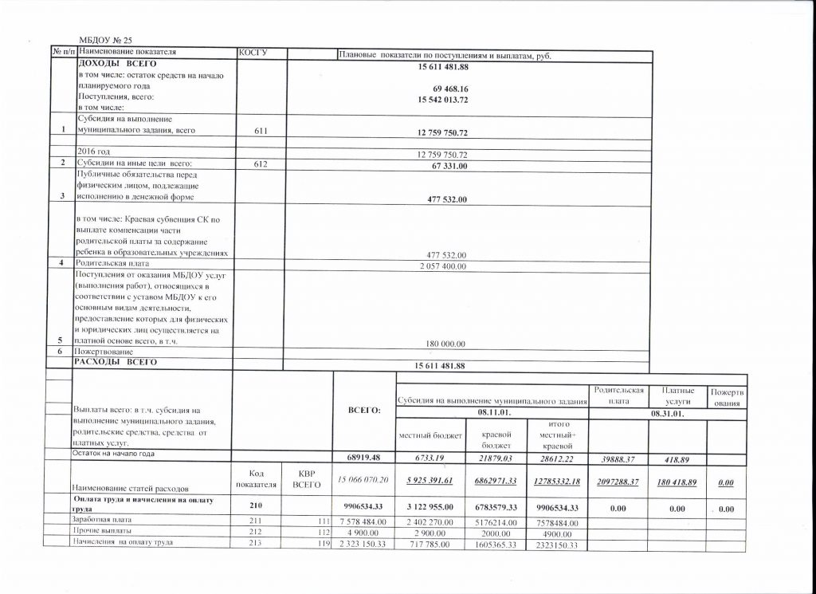](http://ds25.nevinsk.ru/wp-content/uploads/2016/09/3-001.jpg)

[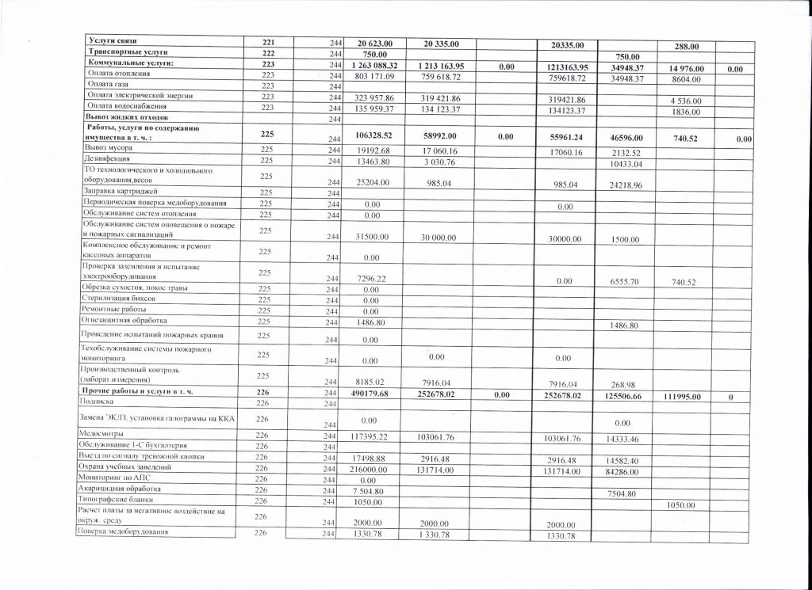](http://ds25.nevinsk.ru/wp-content/uploads/2016/09/4-001.jpg)

[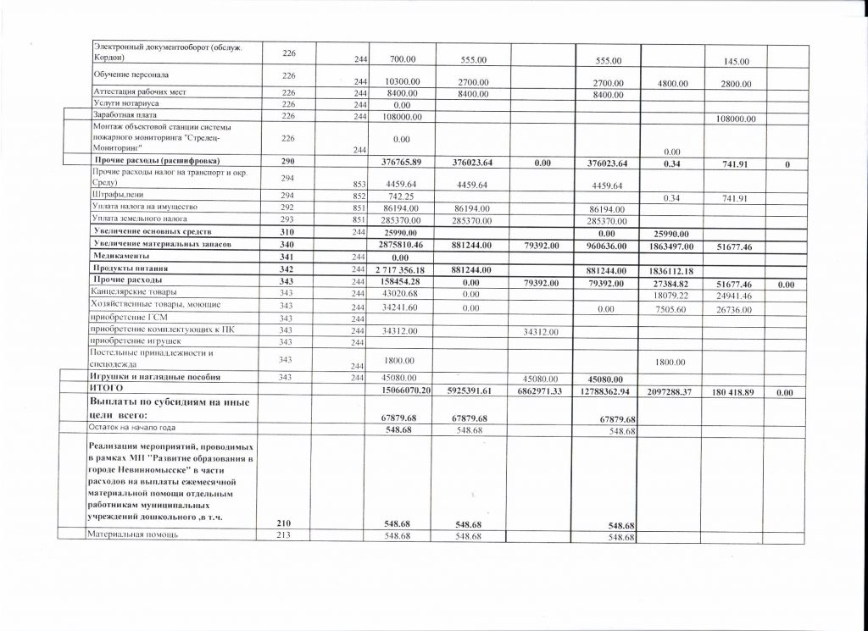](http://ds25.nevinsk.ru/wp-content/uploads/2016/09/5-001.jpg)

[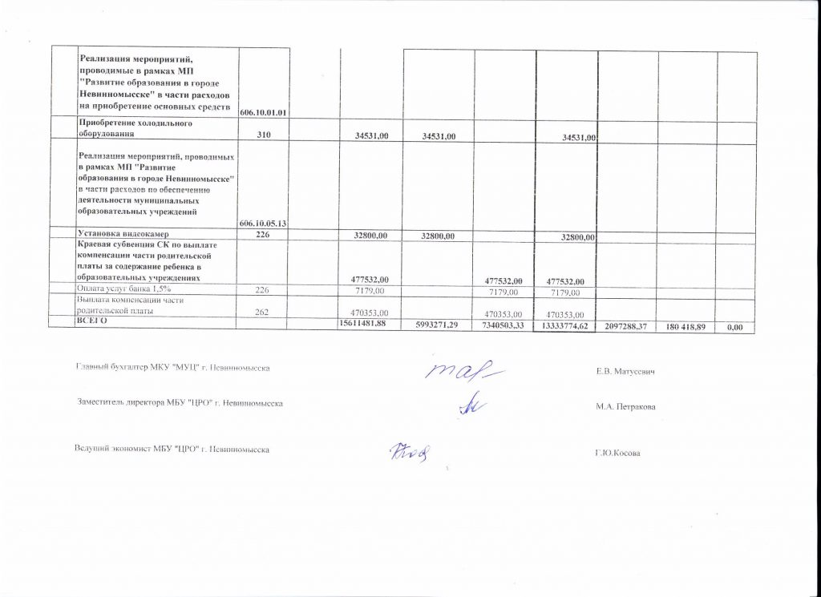](http://ds25.nevinsk.ru/wp-content/uploads/2016/09/6-001.jpg)