[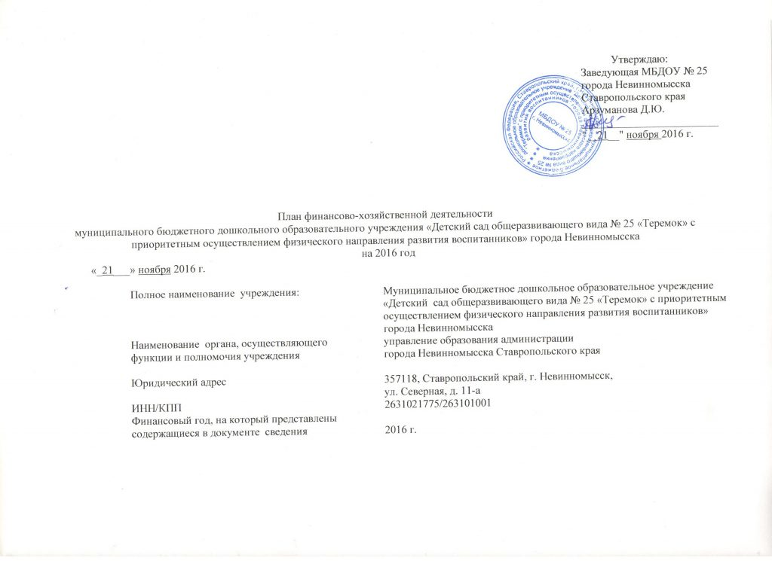](http://ds25.nevinsk.ru/wp-content/uploads/2016/09/%D0%A0%D0%B8%D1%81%D1%83%D0%BD%D0%BE%D0%BA-157.jpg)

[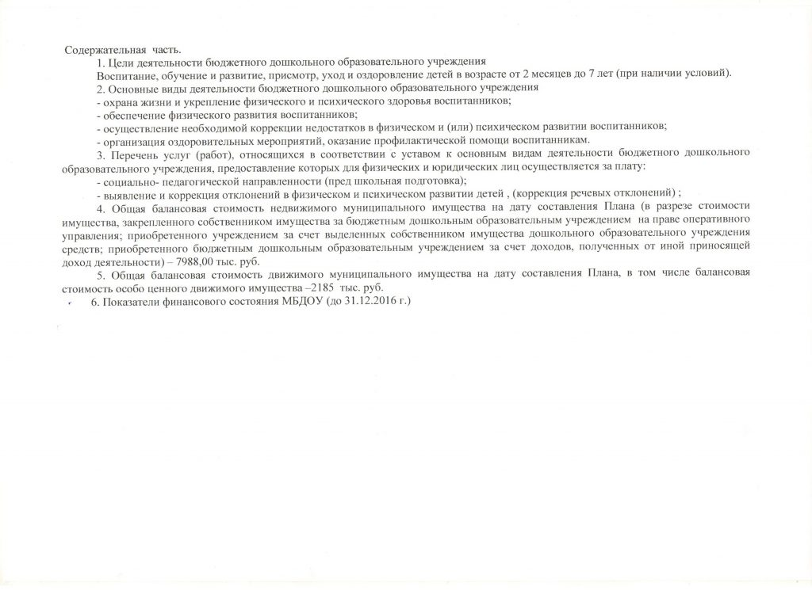](http://ds25.nevinsk.ru/wp-content/uploads/2016/09/%D0%A0%D0%B8%D1%81%D1%83%D0%BD%D0%BE%D0%BA-158.jpg)

[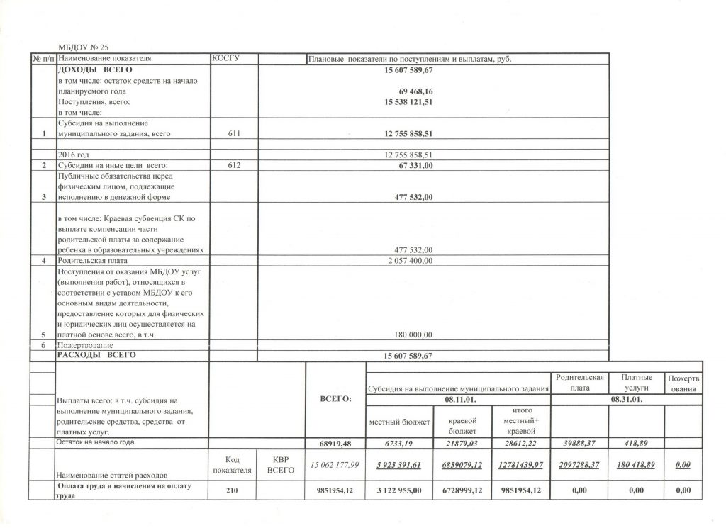](http://ds25.nevinsk.ru/wp-content/uploads/2016/09/%D0%A0%D0%B8%D1%81%D1%83%D0%BD%D0%BE%D0%BA-159.jpg)

[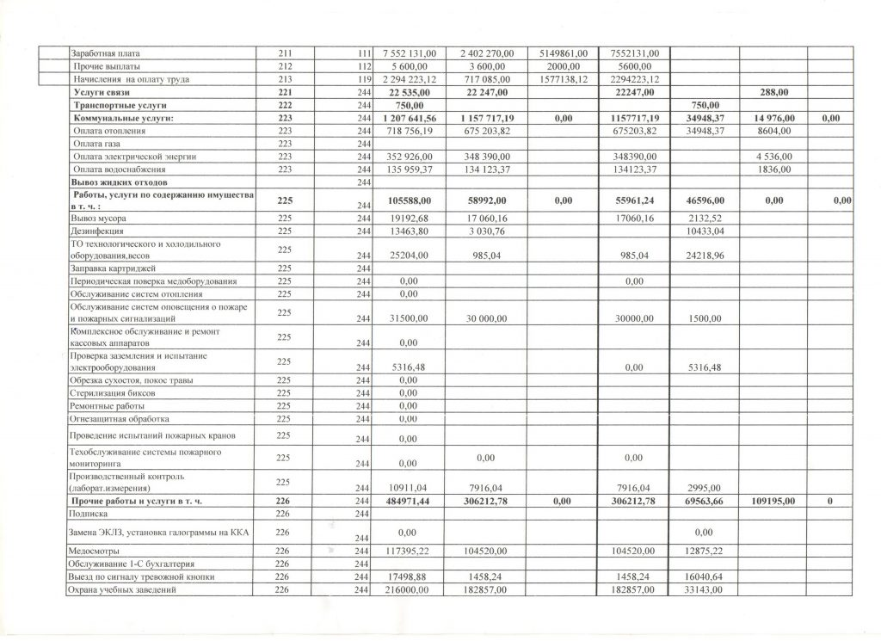](http://ds25.nevinsk.ru/wp-content/uploads/2016/09/%D0%A0%D0%B8%D1%81%D1%83%D0%BD%D0%BE%D0%BA-160.jpg)

[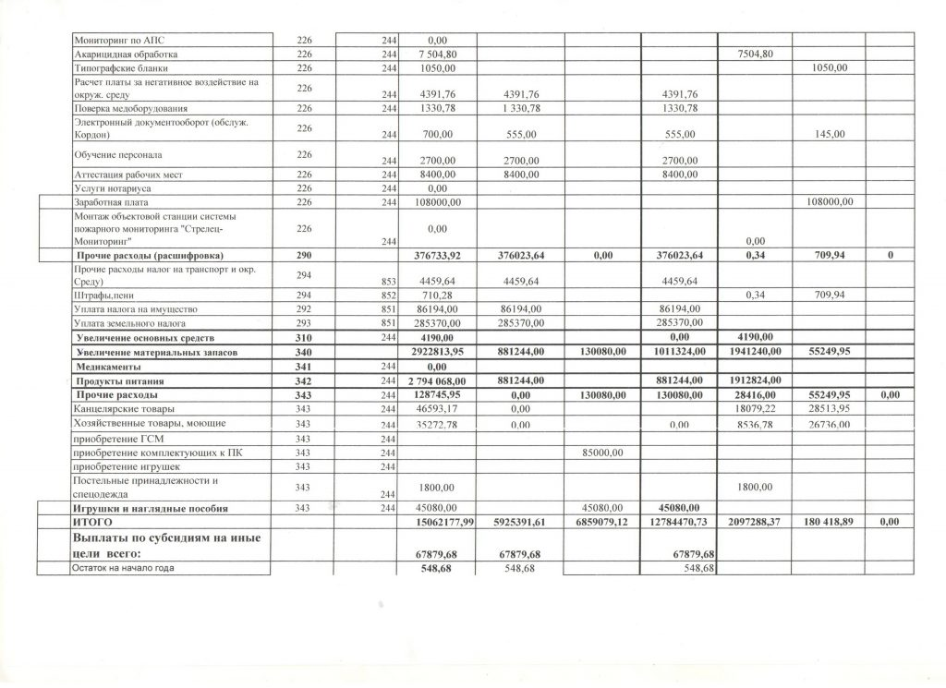](http://ds25.nevinsk.ru/wp-content/uploads/2016/09/%D0%A0%D0%B8%D1%81%D1%83%D0%BD%D0%BE%D0%BA-161.jpg)

[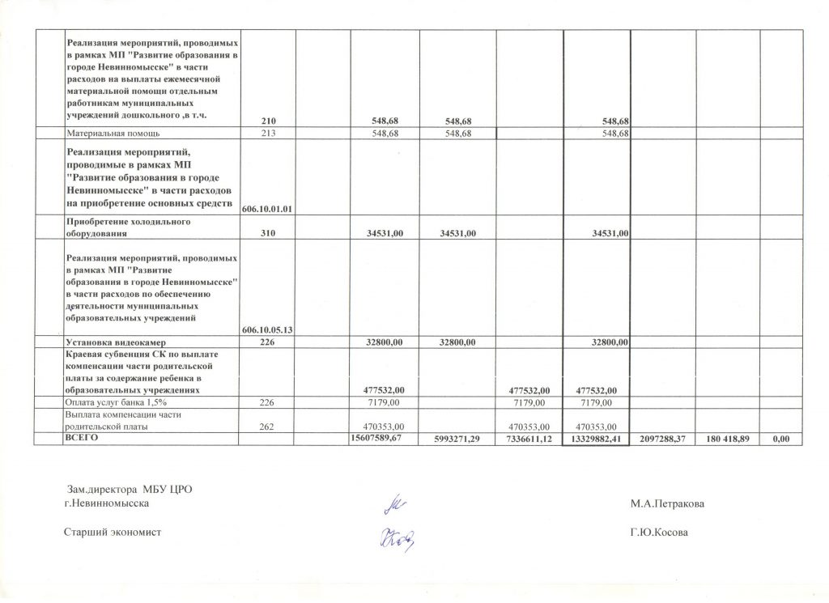](http://ds25.nevinsk.ru/wp-content/uploads/2016/09/%D0%A0%D0%B8%D1%81%D1%83%D0%BD%D0%BE%D0%BA-162.jpg)